THink TOgether Newsletter

Upcoming opportunities for learning and FUN!

7/29/22

Think TOgether

**Welcome to the Think Together AFTER School 2022-2023 School Year at Raymond Cree Middle School!**

Hello Parents and Guardians of Raymond Cree students!  It’s Coach K bringing you another exciting and fun year at Think Together! In this newsletter you will be getting a lot of information about the Think Together Program and the changes that are coming for next year!

For this coming school year the Think Together Program will begin daily at 3:30.  All students should arrive and report to Think Together Room 512 no later than 3:40.  Students are not allowed to leave campus for any reason.  If your student leaves campus, a phone call will be placed to the parent/guardian and the student will need to be picked up immediately.

**Welcome to the Think Together BEFORE School 2022-2023 School Year at Raymond Cree Middle School!**

Think Together and PSUSD have partnered to provide a Safe Space for your students to come to before RCMS officially opens it’s doors at 8:30am.  The Think Together BSP begins at 7:15am for drop off and will close at 8:45am; when all students should be on their way to their first period classes.  Students are to be dropped off at the Staff Entrance on the far side of the building on Avenida de Caballeros.  Room 512 is the Think Together classroom located right by that entrance.

During BSP, students may work on homework, chat with their friends, use the video game room, or work on fun activity sheets **inside the classroom.**  Students will not be allowed to walk around campus.  All students in the BSP must remain inside the classroom that will always supervised by our Program Leaders.  Think Together Staff is here for the safety of your students.  There will be other adults on campus, but they are not required at that time to supervise students within the Think Together Program.  When campus opens at 8:30am, students will be released to start their day at RCMS.

Think Together at RCMS will be offering competitive sports through its LA84 Sports Program.  Sports that will be offered for all students will be flag football, soccer, volleyball and basketball.  Competitions and tournaments will be held against other Think Together Middle School PSUSD  sites.  Look for more information about what sports will be offered in upcoming newsletters!

There will be clubs that students will choose to participate in and run themselves!  Last year's clubs included Cooking, American Sign Language, Board Games, Video Games, Sports and Homework.  In the first few weeks of Program, students will choose and form new clubs for this year.  Each student will be able to participate in 2 clubs 3 to 4 times a week.  Homework Club  will be offered every day for students who need support in their studies.  Each student will have a homework log to fill out daily to show what they were working on and what they have accomplished.

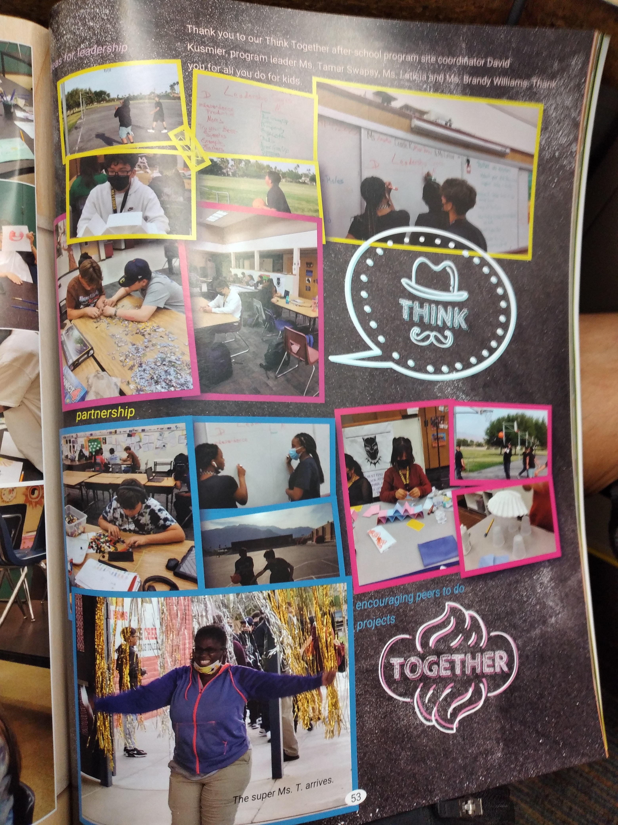

**Please scan the QR Code Below to begin the enrollment process. You only need to fill out one QR Code application (ITA) if you want to enroll in both morning and afterschool program. Once you have completed the QR Code application (ITA), you will receive an email for further information. This may arrive in your junk on spam email folder. Your application is not complete until the email sent by the Site Coordinator is received and the application is competed by you the parent. You may also apply using the blue application forms as well.**

**,**

David S. Kusmier, MA.

“Coach K”

Site Coordinator

1 (442) 295 5985

[raymondcreems.psusd@thinktogether.org](mailto:raymondcreems.psusd@thinktogether.org)

Best,

Coach K

Site Coordinator

1 (442) 295 5985

[raymondcreems.psusd@thinktogether.org](mailto:raymondcreems.psusd@thinktogether.org)

PROGRAM ENROLLMENTFOr BEFORE OR AFTERCSCHOOL Program

THINK TOGETHER